Content based approach to find the credibility of user in social networks an application of cyberbullying

Dataset:

We captured data from Twitter by using our customized crawler written in Python. Data we got from twitter contain direct cyberbullying, indirect cyberbullying, implicit harassment and sarcasm but we focused only on direct and indirect cyberbullying.

Data pre-processing:

1. Missing fields are replaced by NULL.
2. Stemming.
3. There are large numbers of duplicate tweets in dataset. We deleted these duplicated tweets based on Tweet ID.
4. Data we got is also not labelled. Thus we manually labelled the data. The messages we extracted from Twitter are divided into three categories: direct cyberbullying, indirect cyberbullying and no bullying. Now the data of dataset become multiclass.

Feature extraction:

1. Bad words
2. Negative emotions
3. Positive emotions
4. Pronouns
5. Proper nouns
6. Links

Categorization of messages: \*Multiclass classification\*

1. Naive Bayes
2. KNN
3. Decision Tree
4. SVM

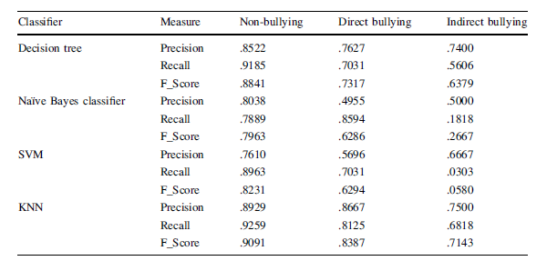

Drawbacks:

Stanford POStagger is not beneficial for large dataset as it becomes very slow during parsing and assigning the tags to each word.

It does not reveal any status of relationship between the users.